Operational Qualification (OQ) Protocol
CannaQ Electronic Quality Management System
Test facility: Northwoods Cannabis Co. (sample data)
Document number | OQ-2026-001
Version | 1.0
Issue date | 2026-06-22
System / build | CannaQ (through Session 76.1)
Scope | Functional verification across all core QMS modules using the companion sample-data workbook
Companion data | CannaQ_OQ_Sample_Data.xlsx — enter values from its tabs as directed in each step
Approvals
Role | Name | Signature | Date
Prepared by
Reviewed by (Quality)
Approved by (Management)

1. Purpose
This protocol verifies that the CannaQ QMS operates as intended across its core functions — supplier control, incoming inspection, inventory and lot traceability, batch production, testing, labeling and release, the connected quality-event workflows, and the Part 11 audit trail. It is executed using the companion sample-data workbook so that records trace end-to-end and intended controls (role gates, e-signatures, fail-closed checks) are demonstrably enforced.

2. Scope
The following modules are covered. Each is verified through normal-path steps and, where applicable, negative (should-be-blocked) steps:
- System access & user setup
- Suppliers & qualification
- Incoming inspections & inventory
- Lot traceability operations
- Recipes & batch production
- Testing / COA entry
- Labeling & release
- Quality events (NC, Complaint, CAPA, Field Action)
- New Quality Event front door & FA request/approval
- Audit trail & record integrity

3. Prerequisites
- A deployed CannaQ instance the tester can reach, on the latest build (through Session 76.1).
- The companion workbook CannaQ_OQ_Sample_Data.xlsx open alongside this protocol.
- Clerk test accounts: use +clerk_test addresses (verification code 424242); no real email is sent.
- Enter data tab-by-tab in workbook order; reuse the exact names, lot numbers and batch numbers so records link.

4. Acceptance Criteria
The OQ passes when every step records a Pass. For a negative (should-be-blocked) step, “Pass” means the system correctly prevented the action with the expected message. Any step that does not behave as expected is recorded as a Fail and logged in the Deviations table (Section 6); each deviation must be dispositioned before the OQ is approved.

5. Test Steps
Shaded Expected Result cells are negative checks — the action must be blocked. Mark P (pass) or F (fail), initial and date each step as executed.

1. System Access & User Setup
Step | Action | Expected Result | P/F | Initial | Date
1.1 | As Admin: Create the 9 test accounts (Workbook → Users & Roles); sign in to each with code 424242. | Each account logs in; new accounts auto-provision as Operator. | P | JS | 6/22/26
1.2 | As Admin: Set each user's role per the workbook. | users.role matches the intended role for each account. | P | JS | 6/22/26
1.3 | As Admin: Add user 'Oscar Pena' with initials 'OP' (already used by Olivia Park). | REJECTED — 409 'Initials “OP” are already in use.' Unique-initials rule enforced (21 CFR Part 11). | P | JS | 6/22/26
1.4 | As Admin: Re-add the same user with initials 'OPe'. | Created successfully; initials now unique. | P | JS | 6/22/26

2. Suppliers & Qualification
Step | Action | Expected Result | P/F | Initial | Date
2.1 | As Quality: Add all 7 suppliers (Workbook → Suppliers). | All saved with type, risk tier and rationale; vendor #7 shows License Pending / not approved. | P | JS | 6/22/26
2.2 | As Quality: Add the 8 supplier qualification records. | Initial quals saved; the 2026-06-01 record surfaces as overdue; the For-Cause review stays open / non-qualified. | P | JS | 6/22/26

3. Incoming Inspections & Inventory
Step | Action | Expected Result | P/F | Initial | Date
3.1 | As Operator: Create INSP-1 through INSP-6 and mark every line item Pass. | An Inventory item appears per passed line item (per-item, idempotent — re-saving Pass does not double-add). | P | JS | 6/22/26
3.2 | As Operator: Create INSP-7 (Sour Diesel) and mark the line item Fail. | NO inventory item is created; the failed receipt is eligible to open an NC. | P | JS | 6/22/26
3.3 | As OperatorAdmin: Confirm Inventory matches the workbook; manually add the two Label items. | Quantities and units match; the Label item type is accepted. | P | JS | 6/22/26
 | 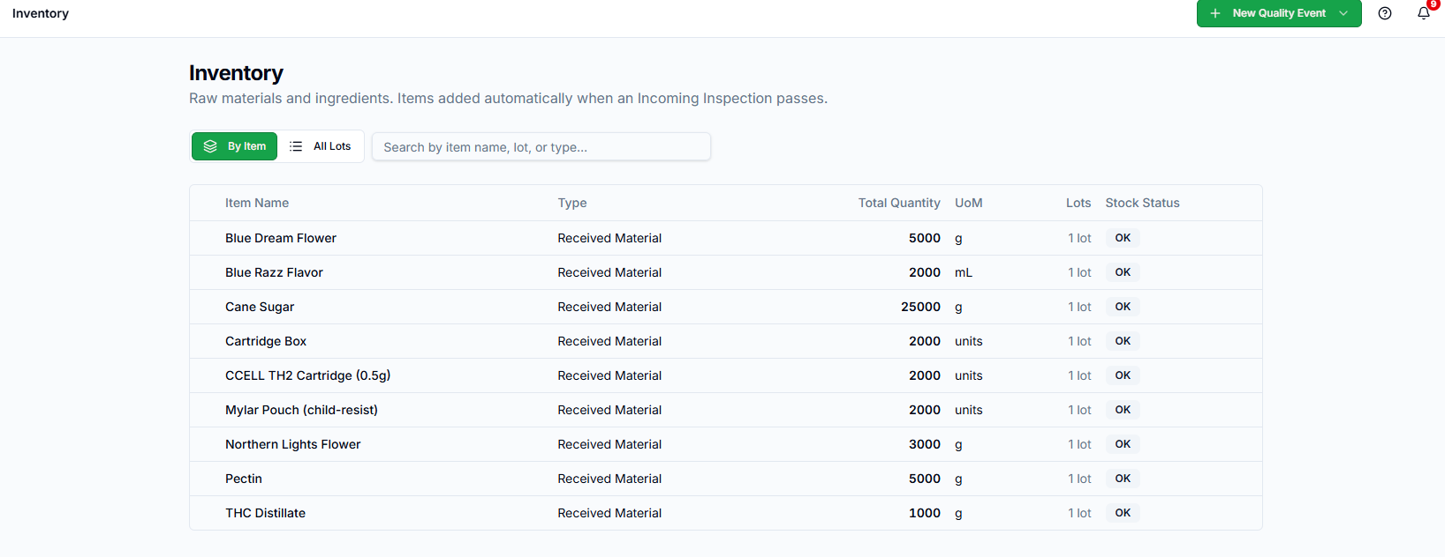 |  | - No way to add inventory items on the inventory page as Operator. When I changed to Admin, I was able to add the items.

4. Lots — Traceability Operations
Step | Action | Expected Result | P/F | Initial | Date
4.1 | As Manager: Split LOT-2026-0001 (5000 g) into 2000 + 1000 with initials + signing meaning. | Parent 5000→2000; two child lots created (Active); events signed. | P | JS | 6/22/26
4.2 | As Operator: Attempt the same split. | BLOCKED — 403 'Lot splits require Manager, Quality, or Admin role.' | P | JS | 6/22/26
4.3 | As Manager: Merge LOT-2026-0003 + LOT-2026-0004 (THC Distillate). | Sources → 0 / Consumed; merged lot = 800 g Active; events signed. | F | Merge not a part of the app
4.4 | As Supervisor: Ship 500 g from LOT-2026-0002. | Current 3000→2500; shipment row created; event logged. | P | JS | 6/22/26
 |  | When creating lots, the information in the fields is not removed from the previous entry.
 |  | Shipping cannabis product (raw and finished) is completed in Metrc. Is this set up in a way to be compatible with Metrc (and I am just creating records manually)? Just wondering how we can make this so its not duplicative documentation and a chance for error.

5. Recipes & Batch Production
Step | Action | Expected Result | P/F | Initial | Date
5.1 | As Quality: Create the 3 recipes; add Bill of Materials and process steps with {blank} fill-ins. | Recipes saved Active; process steps carry fill-in placeholders. | P | JS | 6/22/26
5.2 | As Operator: Open BAT-E1 (gummies) from its recipe; enter the METRC tag. | Batch opens; the entered METRC tag becomes the batch number; Process Type = Kitchen. | F
 |  | The option to create a batch from the recipe is not in the app
5.3 | As Operator: Open BAT-V1 by selecting Product Type = Vape Cartridge (no recipe). | Process Type AUTO-defaults to Inhalants (not Kitchen). | P | JS | 6/22/26
5.4 | As Operator: Run BAT-E1 process steps; sign the heat/cook step as baker. | Baker e-signature captured on the step (FDA attribution). | P | JS | 6/22/26
5.5 | As Operator (unqualified): Attempt to run a recipe the operator is not qualified for, solo. | BLOCKED until the required supervised batches are completed (competency gate). | P | JS | 6/22/26

6. Testing (COA Entry)
Step | Action | Expected Result | P/F | Initial | Date
6.1 | As Quality: Enter COAs for BAT-E1 / P1 / V1 and Mark Test Passed. | Edible records mg/serving; vape/pre-roll record %; batches move to Passed — Awaiting Packaging. | P | JS | 6/22/26
6.2 | As Quality: Enter the BAT-V2 COA (Myclobutanil FAIL) and Mark Test Failed. | Batch moves to Failed; eligible to open NC-2. | P | JS | 6/22/26

7. Labeling & Release
Step | Action | Expected Result | P/F | Initial | Date
7.1 | As Operator: Build the labeling checklist for BAT-E1, then request approval. | An empty / incomplete checklist BLOCKS approval (fail-closed); a complete checklist allows it. | P | JS | 6.22.26
7.2 | As Quality: Approve the BAT-E1 label with e-signature. | Approval recorded with signing meaning; batch can move to release. | P | JS | 6.22.26
 |  | Labeling approved as Operator

8. Quality Events — Connected Flows
Step | Action | Expected Result | P/F | Initial | Date
8.1 | As Operator: From INSP-7, open NC-1 (Reported By = Olivia Park). | NC-1 created; Reported By saved as a user id. | P | JS | 6.22.26
 |  | Reported by saved as Olivia Park
8.2 | As Operator: Attempt to CLOSE NC-1. | BLOCKED — 403 (close requires Supervisor / Manager / Quality / Admin). | P | JS | 6.22.26
8.3 | As Quality: From BAT-V2 open NC-2; escalate NC-2 to a Field Action. | Field Action opens AND a linked CAPA is auto-created (an FA never exists without a CAPA). | P | JS | 6.22.26
8.4 | As Quality: Create CAPA-1; set EC Owner = Quinn Rivera; assign action items to Marcus Reed and Sofia Nguyen. | Owner and assignees saved as user ids (not free text). | P | JS | 6.22.26
8.5 | As Manager + Quality: Take CAPA-1 through Gate 1 using two DISTINCT approver identities. | Gate passes only with two different approvers; a person cannot sign their own / conflicted role (segregation). | P | JS | 6.22.26
8.6 | As Quality: From COMP-1 use 'Create NC from Complaint' (NC-3). | Complaint links to the new NC; the NC shows Related Complaints (both directions). | P | JS | 6.22.26

9. New Quality Event Front Door & FA Approval (Session 76)
Step | Action | Expected Result | P/F | Initial | Date
9.1 | As Operator: Open the top-bar 'New Quality Event' menu. | Menu shows only Non-Conformance, CAPA, and 'Request Field Action' — no direct Field Action or Complaint. | P | JS | 6.22.26
9.2 | As Operator: Submit FA-1 (Stop Sale request on BAT-V1). | FA created in status 'Requested' with NO CAPA; advance / close controls are hidden. | P | JS | 6.22.26
9.3 | As Quality: Open FA-1; Approve the request. | Status → Initiated; the mandatory CAPA is auto-created and linked. | P | JS | 6.22.26
9.4 | As Quality: Open FA-2; Reject with a reason. | Rejection reason required; status → Request Rejected; no CAPA created. | P | JS | 6.22.26
9.5 | As Quality: Open the 'New Quality Event' menu as Quality. | Menu also shows Complaint and Field Action (direct). | P | JS | 6.22.26

10. Audit Trail & Record Integrity
Step | Action | Expected Result | P/F | Initial | Date
10.1 | As Admin: Open the Audit Log for a signed action (label approval or NC close). | Immutable entry: who / what / when / before / after, with acting-user attribution (Part 11). | P | JS | 6.22.26
10.2 | As Manager / Admin: Cancel an NC with a reason + e-signature; then Reopen as Admin. | Soft-cancel (recoverable, audited); records are never hard-deleted; Reopen is Admin-only. | P | JS | 6.22.26

6. Deviations Log
Record any step that failed, the investigation, and its disposition before approving the OQ.
Dev # | Step | Description of deviation | Disposition / resolution
1
2
3
4
5

7. Final Result & Approval
Total steps executed
Steps passed
Steps failed
Overall OQ result (Pass / Fail)

Role | Name | Signature | Date
Executed by
Reviewed by (Quality)
Approved by (Management)

